Here are 3 test files for testing your project.
Below are the test files, and their results.
File Contents | Actual Output
Window "Calculator" (200, 200) Layout Flow:  Textfield 20;  Panel Layout Grid(4, 3, 5, 5):  Button "7";  Button "8";  Button "9";  Button "4";  Button "5";  Button "6";  Button "1";  Button "2";  Button "3";  Label "";  Button "0";  End;  End. | 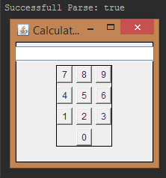

Second example:
Window "Radio Button Test" (300, 200) Layout Grid (5, 1):  Group  Radio "Button 1";  Radio "Button 2";  Radio "Button 3";  Radio "Button 4";  Radio "Button 5";  End;  End. | 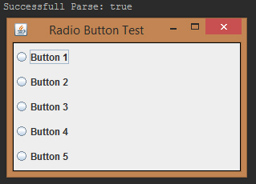

Third example:
Window "Nested Panel Test" (550, 200) Layout Flow:
Label "Main Panel";
Panel Layout Flow:
Panel Layout Flow:
Panel Layout Flow:
Panel Layout Flow:
Button "5th Panel Button";
End;
Button "4th Panel Button";
End;
Button "3rd Panel Button";
End;
Button "2nd Panel button";
End;
End.
